1. Introduction

1. 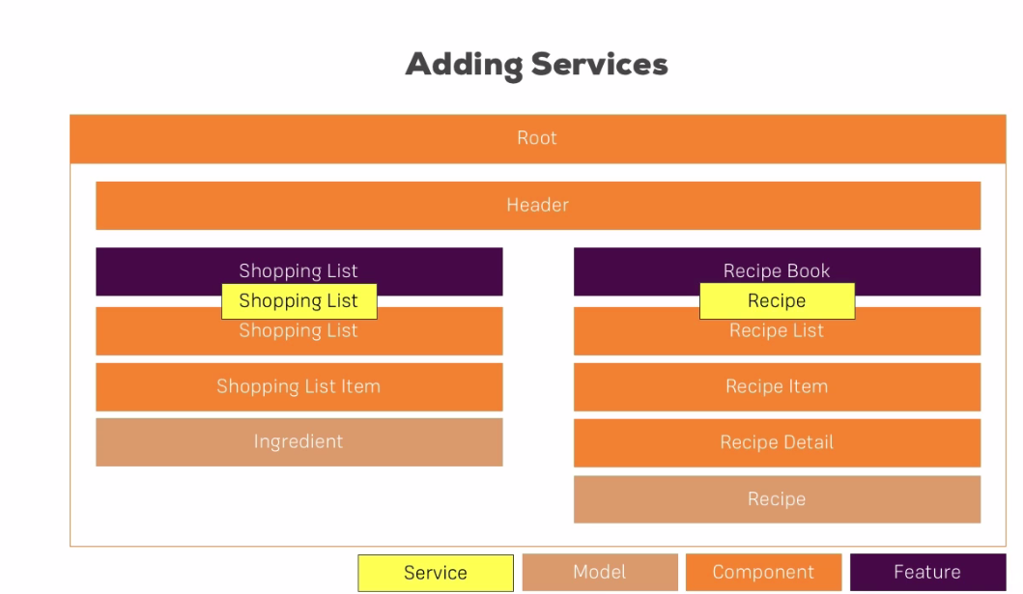
2. Setting up the Services
3. Services are added to the feature folder or next to the feature folder, they belong to.
4. Service is simple Typescript class. No need for any decorator.
5. 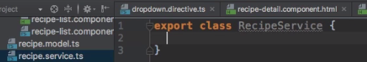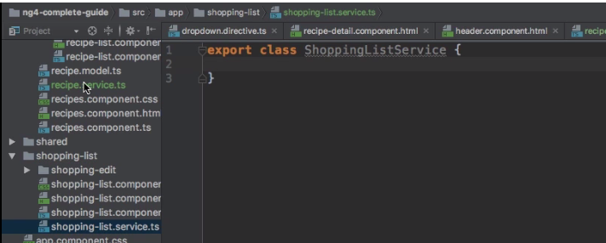

3. Managing Recipes in a Recipe Service

4. Using a Service for Cross-Component Communication